## Accessing CANSIM NDM vectors from Statistics Canada

## [1] 2014 1

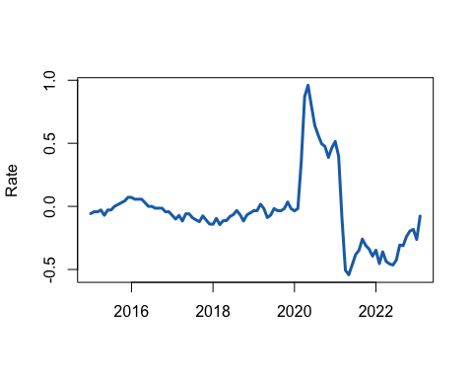

## Accessing CANSIM NDM vectors from Statistics Canada

## [1] 2017 1

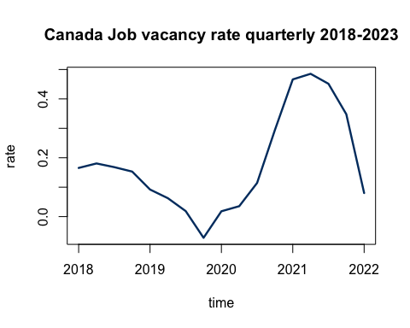

## Accessing CANSIM NDM vectors from Statistics Canada

## [1] 2010 1

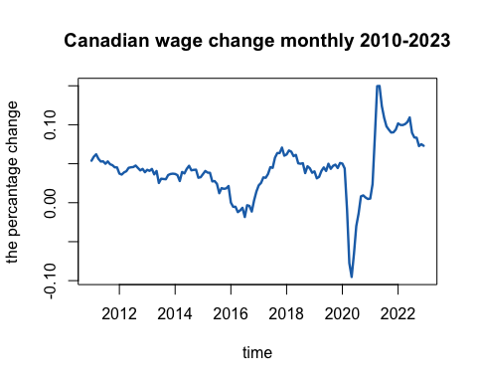

library(readxl)  
The_EI_data_set <- read_excel("/Users/tie/SynologyDrive/nn/ECON-493-forcasting-economy/econ 350/The EI data set.xlsx",   
 sheet = "Combine of the both CPC and EI")

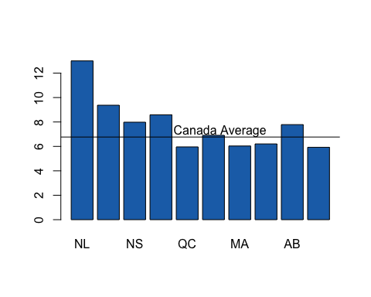

The_EI_data_set <- read_excel("/Users/tie/SynologyDrive/nn/ECON-493-forcasting-economy/econ 350/The EI data set.xlsx",   
 sheet = "Combine of the both CPC and EI")  
  
print(The_EI_data_set, head = 4)

## # A tibble: 24 × 3  
## Year `EI contribution rate for employee` `EI contribution rate for employer`  
## <dbl> <dbl> <dbl>  
## 1 2000 2.4 3.36  
## 2 2001 2.25 3.15  
## 3 2002 2.2 3.08  
## 4 2003 2.1 2.94  
## 5 2004 1.98 2.77  
## 6 2005 1.95 2.73  
## 7 2006 1.87 2.62  
## 8 2007 1.8 2.52  
## 9 2008 1.73 2.42  
## 10 2009 1.73 2.42  
## # … with 14 more rows

CA_CPI_Mothly_raw<- "v41690973"  
 CA_CPI_Mothly_rate <- get_cansim_vector(CA_CPI_Mothly_raw, start_time = "2010-01-01")

## Accessing CANSIM NDM vectors from Statistics Canada

CA_CPI_Mothly_year.st <- year(CA_CPI_Mothly_rate$REF_DATE[1])  
 CA_CPI_Mothly_month.st <- month(CA_CPI_Mothly_rate$REF_DATE[1])  
   
 #transfer data to the time series time  
 c(CA_CPI_Mothly_year.st, CA_CPI_Mothly_month.st)

## [1] 2010 1

CA_CPI_Mothly.ts<- ts (CA_CPI_Mothly_rate$VALUE,   
 start = c(CA_CPI_Mothly_year.st, CA_CPI_Mothly_month.st),   
 freq = 12)  
  
   
   
 CA_CPI_Mothly.ts.yoy <- diff(log(CA_CPI_Mothly.ts), 12)  
 plot(CA_CPI_Mothly.ts.yoy, type = "l",col="#1D70B6",lwd=2.4, ylab = "rate", xlab = "")

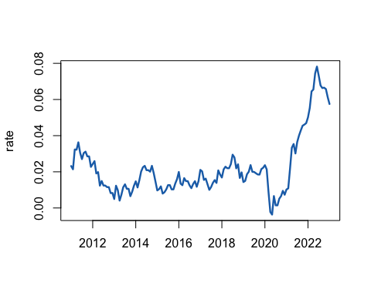

#Canada CPI year over year change 2010 - 2023